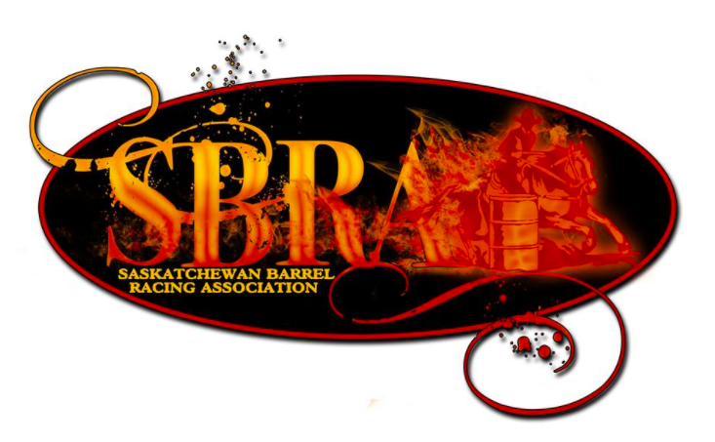
SBRA
Box 1793
Meadow Lake, SK.
S9X 1Z2

We are thrilled to invite you to be one of the sponsors for our 2024 Saskatchewan Barrel Racing Finals. We will be hosting our annual finals (30+ years) at Moose Jaw Exhibition Grounds on August 12- August 15, 2024. We are excited to have our finals in Moose Jaw again this year as it was such a success last year.
The Saskatchewan Barrel Racing Association was founded in 1991 to help promote the sport of barrel racing. We encourage every level and age of barrel racer, with our 4D system; it allows everyone a chance to win whether very competitive, just starting out, or just wanting to have fun.
Since we originated our association has grown to 1000+ members, with the majority of the membership attending our finals. We have a great board of directors that meet throughout the year to plan the annual finals. Together we make sure our competitors follow the rules and regulations, and make sure our finals are ran smooth and proficient.

Our goal is to collect cash sponsorship for several trophy prizes and cash payout to be divided up between our Youth, Open and Select age categories. Your sponsorship will help make our finals memorable for hundreds of Saskatchewan Barrel Racers. Attached is a letter with our different levels of sponsorship available.

We look forward to an affirmative response of sponsorship from you to make this event a success. Please contact us if you have any questions regarding our association or finals.
Sincerely,
Amanda Porter
S.B.R.A President
306-434-5770
Porter.amanda@outlook.com

